Technical Specification
Table of Contents
Overview 3
System Characteristics 3
System Architecture 3
Application Architecture 3
Hardware Requirements 3
Software Requirements 3
Servers 3
Clients 3
Installation Instructions 4
System Configuration 4
System Parameters 4
Detailed Design 4
User Interface 4
Screens 4
Reports 5
Business Services 5
Diagram 5
Batch Processing 5
Scripts 5
Business Processes 5
Data 5
File Structure 5
Extract Functionality 5
Export Functionality 5
Schema Objects 5
Table Descriptions 5
Data Mapping 5
Security 5
Backup and Recovery 5
Appendix 5

Overview
This document describes the technical specification of the NBooks project.

System Characteristics

System Architecture

Application Architecture

Hardware Requirements

Software Requirements
We assume the system will run on a minimal setup. This section describes the software requirements for servers and clients for using NBooks application.

Servers
- WinXP, Win7, (haven’t tested on Win2000 but will do as this is the server-based OS for Windows)
- MySQL Server

Clients
- WinXP, Win7
- Visual Studio (VS.NET) 2008
- SharpDevelop, alternative for VS.NET, you will install manually the:
  - .Net Framework 3.5
  - Crystal Reports Runtime
- TortoiseSVN
- Toad for MySQL
- Notepad++
- MySQL ODBC Driver
- 7zip

Installation Instructions

System Configuration

System Parameters

Detailed Design

User Interface

Screens

Login Form

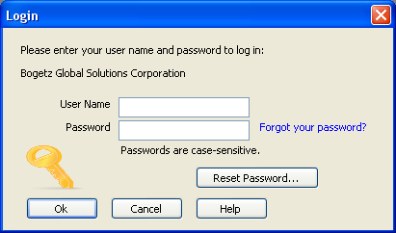

Company Form
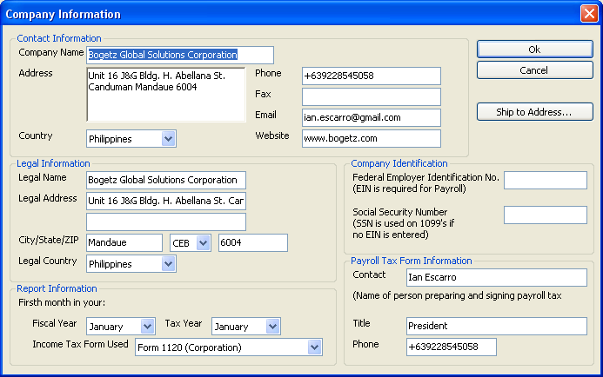

Customer Form
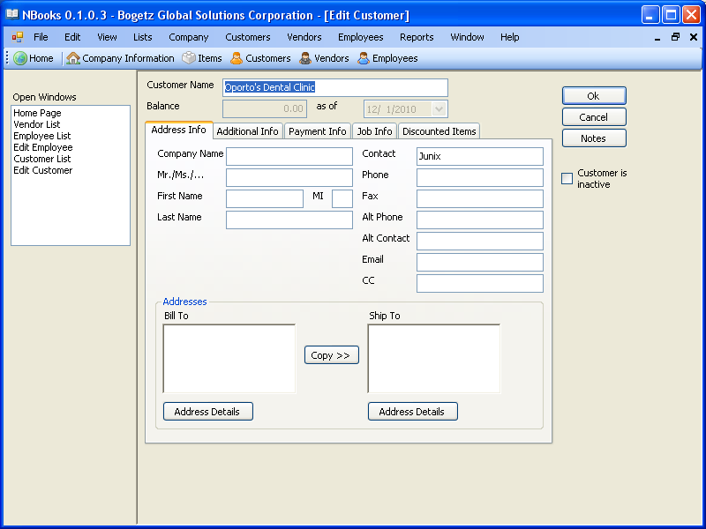

Vendor Form
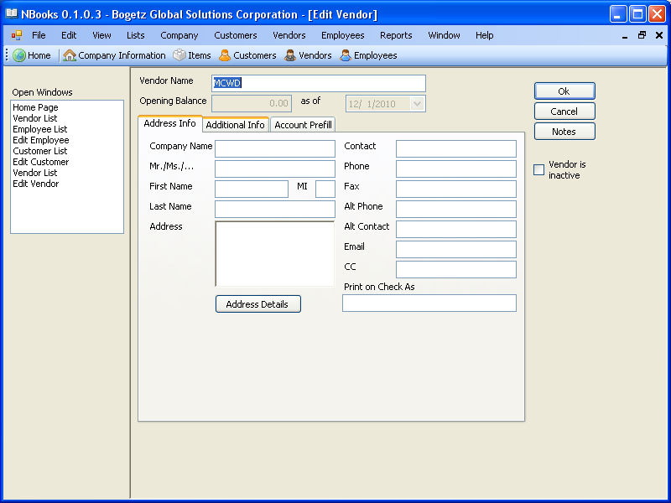

Reports

Business Services

Diagram

Batch Processing

Scripts

Business Processes

Data

File Structure

Extract Functionality

Export Functionality

Schema Objects

Table Descriptions

Data Mapping

Security

Backup and Recovery

Appendix

